# Introduction to E-Commerce

The term "**Electronic commerce**" (or *e-Commerce*) refers to the use of an electronic medium to carry out commercial transactions. Most of the time, it refers to the sale of products via Internet, but the term *eCommerce* also covers purchasing mechanisms via Internet (for B-To- B).

A client who purchases on the Internet is called a **cyberconsumer**. *E-Commerce* is not only limited to online sales, but also covers:

* Preparation of estimates online
* Consulting of users
* Provision of an electronic catalog
* Access plan to point of sales
* Real-time management of product availability (stock)
* Online payment
* Delivery tracking
* After-sales service

In certain cases, electronic commerce makes it possible to highly customize products, in particular when the electronic commerce site is linked with the production system of the enterprise (e.g. business cards, customized items such as T-shirts, cups, caps, etc.)

Finally, insofar as electronic services and products are concerned (MP3 files, software programs, e-books, etc.), electronic commerce makes it possible to receive the purchase in a very short time, if not immediately.

Electronic commerce (e-commerce) remains a relatively new, emerging and constantly changing area of business management and information technology. E-commerce is digitally enabled commercial transactions between and among organizations and individuals. *Digitally enabled transactions* include all transactions mediated by digital technology e.g. Internet. For the most part, this means transactions that occur over the Internet and the Web. *Commercial transactions* involve the exchange of value (e.g., money) across organizational or individual boundaries in return for products and services. Exchange of value is important for understanding the limits of e-commerce. Without an exchange of value, no commerce occurs.

Some of the definitions of e-commerce often heard and found in publications and the media are:

* + Electronic Commerce (EC) is where business transactions take place via telecommunications networks, especially the Internet.
  + Electronic commerce describes the buying and selling of products, services, and information via computer networks including the Internet.
  + Electronic commerce is about doing business electronically.
  + E-commerce is defined as the conduct of a financial transaction by electronic means.
  1. **Comparison between E-Commerce and traditional Commerce**

Traditional Commerce or Commerce is a part of business, which encompasses all those activities that facilitate exchange. Two kinds of activities are included in commerce, i.e. trade and auxiliaries to trade. The term trade refers to the buying and selling of goods and services for cash or kind and auxiliaries to trade, implies all those activities like banking, insurance, transportation, advertisement, insurance, packaging, and so on, that helps in the successful completion of exchange between parties.

In finer terms, commerce encompasses all those activities that simplify the exchange of goods and services, from manufacturer to the final consumer. When the goods are produced, it does not reach to the customer directly rather it has to pass from various activities, which are included under commerce. Its main function is to satisfy the wants of consumers by making goods available to them, at the right time and place.

Electronic commerce is very much like traditional commerce. It also involves an exchange of goods. But the exchange of goods is conducted online. Technologies such as email, electronic data interchange and electronic fund transfer are used to track transactions and receive payments. Some of the differences between electronic commerce and traditional commerce are explained briefly below:

***Difference between E-Commerce and Traditional Commerce***

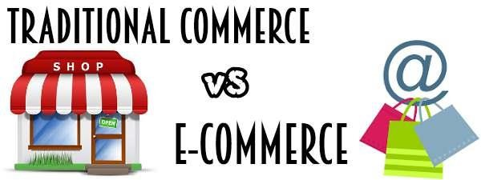

## Cost effective

E-commerce is very cost effective when compared to traditional commerce. In traditional commerce, cost has to be incurred for the role of middlemen to sell the company’s product. The cost incurred on middlemen is eliminated in e-commerce as there is a direct link between the business and the customer. The total [overhead cost](http://accountlearning.com/what-is-overhead-meaning-importance-classification/) required to run e-business is comparatively less, compared to traditional business.

For example, in running an e-business, only a head office is required. Whereas in traditional method, a head office with several branches are required to cater to the needs of customers situated in different places. The cost incurred on labour, maintenance, office rent can be substituted by hosting a website in e-business method.

## Time saving

It takes a lot of time to complete a transaction in traditional commerce. E-commerce saves a lot of valuable time for both the consumers and business. A product can be ordered and the transaction can be completed in few minutes through internet.

## Convenience

E-commerce provides convenience to both the customers and the business. Customers can browse through a whole directories of catalogues, compare prices between products and

choose a desired product anytime and anywhere in the world without any necessity to move away from their home or work place.

E-commerce provides better connectivity for its prospective and potential customers as the organization’s website can be accessed virtually from anywhere, any time through internet. It is not necessary to move away from their work place or home to locate and purchase a desired product.

## Geographical accessibility

In traditional commerce, it may be easy to expand the size of the market from regional to national level. Business organizations have to incur a lot of expenses on investment to enter international market. In e-commerce it is easy to expand the size of the market from regional to international level.

By hosting a website, by placing advertisements on the internet and satisfying certain legal norms, a business can penetrate into global market. It is quite easy to attract customers from global markets at a marginal cost.

## Introduction of new products

In traditional commerce, it takes a lot of time and money to introduce a new product and analyze the response of the customers. Initially, cost has to be incurred to carry out pilot surveys to understand the taste of the customers.

In e-commerce, it is easy to introduce a product on the website and get the immediate feedback of the customers. Based on the response, the products can be redefined and modified for a successful launch.

## Profit

E-commerce helps to increase the sales of the organization. It helps the organization to enjoy greater profits by increasing sales, cutting cost and streamlining operating processes.

The cost incurred on the middlemen, overhead, inventory and limited sales pulls down the profit of the organization in traditional commerce.

## Physical inspection

E-commerce does not allow physical inspection of goods. In purchasing goods in e- commerce, customers have to rely on electronic images whereas in traditional commerce, it is possible to physically inspect the goods before the purchase.

## Time accessibility

Business is open only for a limited time in traditional commerce. Round the clock (24 x 7) service is available in e-commerce.

## Product suitability

E-commerce is not suitable for perishable goods and high valuable items such as jewelry and antiques. It is mostly suitable for purchasing tickets, books, music and software. Traditional commerce is suitable for perishables and touch and feel items. Purchasing software, music in traditional commerce may appear expensive,

## Human resource

To operate in electronic environment, an organization requires technically qualified staff with an aptitude to update them in the ever changing world. E-business has difficulty in recruiting and retaining talented people.

Traditional commerce does not have such problems associated with human resource in non electronic environment.

## Customer interaction

In traditional commerce, the interaction between the business and the consumer is a “face-to- face”.

In electronic commerce, the interaction between the business and the consumer is “screen-to- face”. Since there is no personal touch in e-business, companies need to have intimate relationship with customers to win over their loyalty.

## Process

There is an automated processing of business transactions in electronic commerce. It helps to minimize the clerical errors.

There is manual processing of business transactions in traditional commerce. There are chances of clerical errors to occur as human intervention takes place.

## Business relationship

The business relationship in traditional commerce is vertical or linear, whereas in electronic commerce the business relationship is characterized by end-to-end.

## Fraud

Lots of cyber frauds take place in electronic commerce transactions. People generally fear to give credit card information. Lack of physical presence in markets and unclear legal issues give loopholes for frauds to take place in e-business transactions.

Fraud in traditional commerce is comparatively less as there is personal interaction between the buyer and the seller.

**Comparison Chart**

|  |  |  |
| --- | --- | --- |
| BASIS FOR COMPARISON | TRADITIONAL COMMERCE | E-COMMERCE |
| Meaning | Traditional commerce is a branch of business which focuses on the exchange of products and services, and includes all those activities which encourages exchange, in some way or the other. | e-Commerce means carrying out commercial transactions or exchange of information, electronically on the internet. |
| Processing of Transactions | Manual | Automatic |
| Accessibility | Limited Time | 24×7×365 |

|  |  |  |
| --- | --- | --- |
| BASIS FOR COMPARISON | TRADITIONAL COMMERCE | E-COMMERCE |
| Physical inspection | Goods can be inspected physically before purchase. | Goods cannot be inspected physically before purchase. |
| Customer interaction | Face-to-face | Screen-to-face |
| Scope of business | Limited to particular area. | Worldwide reach |
| Information exchange | No uniform platform for exchange of information. | Provides a uniform platform for information exchange. |
| Resource focus | Supply side | Demand side |
| Business Relationship | Linear | End-to-end |
| Marketing | One way marketing | One-to-one marketing |
| Payment | Cash, cheque, credit card, etc. | Credit card, fund transfer etc. |
| Delivery of goods | Instantly | Takes time |

* 1. **Elements of E-Commerce application**

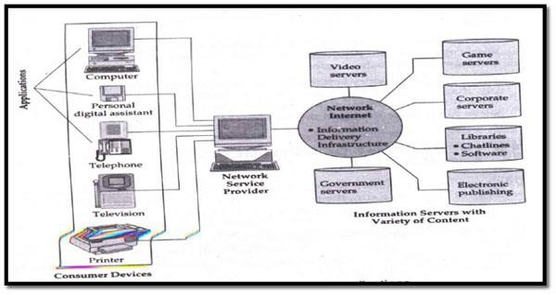

**E-commerce Framework:**

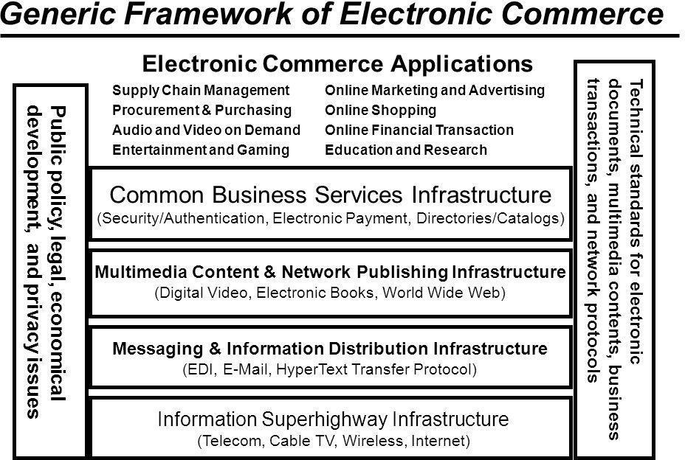

* 1. **Advantages and disadvantages of E-Commerce**

**BENEFITS OF E-COMMERCE**

The benefits of e-commerce can be seen to affect three major stakeholders: organizations, consumers and society.

## Benefits of e-commerce to organizations

* + 1. ***International marketplace*.** What used to be a single physical marketplace located in a geographical area has now become a borderless marketplace including national and international markets. By becoming e-commerce enabled, businesses now have access to people all around the world.
    2. ***Operational cost savings*.** The cost of creating, processing, distributing, storing and retrieving paper-based information has decreased.
    3. ***Mass customization*.** E-commerce has revolutionized the way consumers buy well and services. In the past when Ford first started making motor cars, customers could have any color so long as it was black. Now customers can configure a car according to their specifications within minutes on-line via the [www.ford.com](http://www.ford.com/) website.
    4. ***Enables reduced inventories*** and overheads by facilitating ‘pull’-type supply chain management – this is based on collecting the customer order and then delivering through JIT (just-in-time) manufacturing. This is particularly beneficial for companies in the high technology sector, where stocks of components held could

quickly become obsolete within months. For example, companies like Motorola (mobile phones), and Dell (computers) gather customer orders for a product, transmit them electronically to the manufacturing plant where they are manufactured according to the customer’s specifications (like color and features) and then sent to the customer within a few days.

* + 1. ***Lower telecommunications cost*.** The Internet is much cheaper than value added networks (VANs) which were based on leasing telephone lines for the sole use of the organization and its authorized partners. It is also cheaper to send a fax or e- mail via the Internet than direct dialing.
    2. ***Digitization of products and processes*.** Particularly in the case of software and music/video products, this can be downloaded or e-mailed directly to customers via the Internet in digital or electronic format.
    3. ***No more 24-hour-time constraints*.** Businesses can be contacted by or contact customers or suppliers at any time.

## Benefits of e-commerce to consumers

* + 1. ***24/7 access*.** Enables customers to shop or conduct other transactions 24 hours a day, all year round from almost any location. For example, checking balances, making payments, obtaining travel and other information.
    2. ***More choices*.** Customers not only have a whole range of products that they can choose from and customize, but also an international selection of suppliers.
    3. ***Price comparisons*.** Customers can ‘shop’ around the world and conduct comparisons either directly by visiting different sites. (For example [www.moneyextra.co.uk](http://www.moneyextra.co.uk/) for financial products and services).
    4. ***Improved delivery processes*.** This can range from the immediate delivery of digitized or electronic goods such as software or audio-visual files by downloading via the Internet, to the on-line tracking of the progress of packages being delivered by mail or courier.
    5. ***An environment of competition*** where substantial discounts can be found or value added, as different retailers for customers.

## Benefits of e-commerce to society

* + 1. ***Enables more flexible working practices*,** which enhances the quality of life for a whole host of people in society, enabling them to work from home. It also potentially reduces environmental pollution as fewer people have to travel to work regularly.
    2. ***Connects people*.** Enables people in developing countries and rural areas to enjoy and access products, services, information and other people which otherwise would not be so easily available to them.
    3. ***Facilitates delivery of public services*.** For example, health services available over the Internet (on-line consultation with doctors or nurses), filing taxes over the Internet through the Inland Revenue website.

**Media Convergence**

1. **Definition**:
   * Media convergence refers to the merging of traditional media (newspapers, television, radio) with digital and online platforms. It encompasses the blending of various forms of media, content, and communication channels to create a unified and interactive experience for users.
2. **Types of Media Convergence**:
   * **Technological Convergence**: Integration of different technologies into a single device (e.g., smartphones combining camera, phone, and internet functionalities).
   * **Economic Convergence**: Merging of companies or industries to create synergies (e.g., mergers of telecom and media companies).
   * **Cultural Convergence**: Shared cultural experiences across different media platforms (e.g., viral videos, memes).
   * **Global Convergence**: Spread of media content and technology across the world, reducing geographical barriers.
3. **Impact on E-commerce**:
   * Enhances user experience with rich media content.
   * Facilitates cross-platform marketing and advertising.
   * Increases reach and engagement with global audiences.

**Business Applications of E-commerce**

1. **Online Retailing**:
   * Selling products and services directly to consumers via online platforms (e.g., Amazon, eBay).
2. **Electronic Marketplaces**:
   * Platforms that connect buyers and sellers, facilitating transactions (e.g., Alibaba, Etsy).
3. **Internet Banking and Financial Services**:
   * Providing banking services, loans, and investment options online (e.g., PayPal, online banking portals).
4. **Supply Chain Management**:
   * Managing the flow of goods, information, and finances through digital platforms to streamline operations (e.g., SAP (Systems, Applications & Products in Data Processing), Oracle SCM).
5. **Customer Relationship Management (CRM)**:
   * Using online tools to manage customer interactions, support, and data analytics to improve customer satisfaction and retention (e.g., Salesforce).
6. **Digital Marketing and Advertising**:
   * Leveraging online channels such as social media, search engines, and email to promote products and services (e.g., Google Ads, Facebook Ads).
7. **Online Auctions**:
   * Platforms that allow users to bid on and purchase items in real-time (e.g., eBay auctions).
8. **Content Delivery and Streaming Services**:
   * Providing digital content like movies, music, and books through online subscriptions or purchases (e.g., Netflix, Spotify).

**Need for E-commerce and E-business**

1. **Global Reach**:
   * E-commerce allows businesses to reach customers worldwide, breaking geographical barriers.
2. **Cost Efficiency**:
   * Reduces the need for physical stores and associated overhead costs.
3. **24/7 Availability**:
   * Online platforms are accessible anytime, providing convenience to customers and increasing sales opportunities.
4. **Personalization and Customer Engagement**:
   * Data analytics enable personalized marketing and improved customer experiences.
5. **Speed and Efficiency**:
   * Automates and streamlines business processes, reducing transaction times and improving efficiency.
6. **Scalability**:
   * E-commerce platforms can easily scale to handle increased traffic and transactions.
7. **Enhanced Data Collection and Analysis**:
   * Provides valuable insights into customer behavior and preferences, aiding in decision-making and strategy formulation.
8. **Competitive Advantage**:
   * Businesses can stay competitive by adopting the latest technologies and trends in e-commerce.

**Basics of E-commerce: Network and Electronic Transactions Today**

1. **Network Infrastructure**:
   * **Internet**: The primary network that facilitates e-commerce, connecting users globally.
   * **Intranet**: Internal networks used by companies for secure communications and transactions.
   * **Extranet**: Extends intranets to external partners for business collaboration.
2. **Electronic Transactions**:
   * **Online Payments**: Secure payment gateways and methods (e.g., credit/debit cards, digital wallets, cryptocurrencies).
   * **Security Protocols**: SSL/TLS for secure communications, encryption for data protection.
   * **Authentication and Authorization**: Ensuring the identity of users and granting access to resources.
3. **E-commerce Platforms**:
   * **Custom-built Solutions**: Tailored platforms designed for specific business needs.
   * **Off-the-shelf Solutions**: Ready-to-use platforms like Shopify, Magento, WooCommerce.
4. **Legal and Regulatory Aspects**:
   * Compliance with data protection laws (e.g., GDPR (General Data Protection Regulation) , CCPA (California Consumer Privacy Act)).
   * Adherence to consumer protection regulations and online business standards.

**M-commerce and Its Applications**

1. **Definition**:
   * Mobile commerce (m-commerce) refers to the buying and selling of goods and services through mobile devices like smartphones and tablets.
2. **Key Features**:
   * **Mobility**: Access and conduct transactions from anywhere.
   * **Personalization**: Tailored experiences based on user preferences and behavior.
   * **Location-based Services**: Providing relevant offers and services based on the user’s location.
3. **Applications of M-commerce**:
   * **Mobile Banking and Payment**:
     + Conduct financial transactions, transfer money, and pay bills via mobile apps (e.g., Apple Pay, Google Wallet).
   * **Mobile Shopping**:
     + Purchase products and services through mobile apps or websites (e.g., Amazon app, eBay mobile).
   * **Mobile Marketing**:
     + Targeted advertising and promotions through SMS, push notifications, and mobile ads.
   * **Mobile Ticketing**:
     + Book and receive tickets for events, travel, and entertainment on mobile devices (e.g., airline boarding passes, concert tickets).
   * **Location-based Services**:
     + Offer deals and services based on the user’s real-time location (e.g., nearby restaurant discounts).
   * **Mobile Health (mHealth)**:
     + Access healthcare services, book appointments, and receive medical advice through mobile apps (e.g., telemedicine apps).
4. **Advantages of M-commerce**:
   * **Convenience**: Users can shop, pay, and access services anytime, anywhere.
   * **Speed**: Fast transactions and real-time updates.
   * **Personalization**: Enhanced user experience through personalized recommendations and services.
   * **Engagement**: Increased customer interaction and loyalty through mobile apps and services.
5. **Challenges of M-commerce**:
   * **Security Concerns**: Ensuring data protection and secure transactions on mobile devices.
   * **Device Compatibility**: Adapting applications for different mobile platforms and devices.
   * **User Experience**: Designing intuitive and user-friendly mobile interfaces.
   * **Connectivity**: Dependence on reliable internet and mobile network connections.

Electronic commerce and mobile commerce have transformed how businesses operate and interact with customers, offering numerous benefits such as global reach, cost efficiency, and enhanced customer engagement. As technology continues to evolve, the importance and applications of e-commerce and m-commerce will only grow, providing new opportunities for innovation and growth.